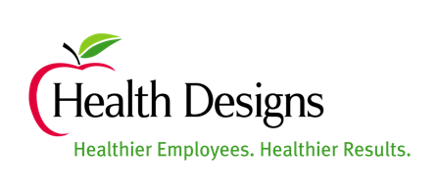

FOR IMMEDIATE RELEASE Contact: Britnee Bell, Director of
August 4, 2021 Business Development
britnee@healthdesigns.net
904-285-2019

National Association for Business Resources Names the Summer 2021 List of Nation’s Best and Brightest in Wellness Winners
PONTE VEDRA BEACH, FL —Health Designs has once again been recognized as one of the Nation’s Best and Brightest in Wellness.
The National Association for Business Resources has released their 2021 Nation’s Best and Brightest in Wellness winners. This program honors companies that promote employee well-being, worksite health and wellness and Health Designs is honored to be recognized amongst the best!
The 2021 Summer National winning companies were evaluated by an assessment created and administered by SynBella, the nation’s leading wellness systems firm. Company entries are examined statistically for quantitative and qualitative data. Each survey was scored on a point system based upon criteria to benchmark and improve wellness program effectiveness. They include outcomes, analysis, tracking, participation & incentives, benefits and programs, leadership, employee input, culture and environment.
With over 20 years of experience conducting the Best and Brightest competitions, the National Association for Business Resources (NABR) has identified numerous best practices and provided benchmarking for companies that continue to be leaders in employment standards.
This year, the Nation’s Best and Brightest in Wellness released the results of the summer applicants in August and fall applicants are to be released in December. The summer competition of The Nation’s Best and Brightest Program is honoring 35 winning organizations from across the country. The fall scoring process is still currently open and those winners will be announced in December. These winning companies will be honored during the Illuminate Business Summit week long celebration November 1-4, 2021. The virtual Illuminate Business Summit will feature award celebrations, networking, education, and inspiration.
“The Best and Brightest is a powerful community of elite leaders who share ideas and practices, and have proven they are employers of choice. Best and Brightest winning companies have also been a voice for important action in creating a sustainable culture that works and ensuring the wellbeing of their employees come first,” said Jennifer Kluge, President and CEO, Best and Brightest Programs.

About the Best and Brightest in Wellness® Program
The Best and Brightest in Wellness, a program of the National Association for Business Resources, celebrates those companies that are making their businesses flourish, the lives of their employees better and the community a healthier place to live. The Best and Brightest program provides year-long education, benchmarking, assessment tools and interaction amongst the best employers. Nominations are now being accepted for the 2021 programs. Visit www.thebestandbrightest.com for more information.

About Health Designs

Health Designs is a worksite wellness partner with the most highly credentialed wellness team in the industry. Headquartered in Ponte Vedra Beach, Florida, they have been providing comprehensive well-being services to companies nationwide for over 26 years. Their principle service offerings range from comprehensive worksite wellness solutions to supplemental service offerings. Their longstanding client relationships, high level of referrals, and near daily feedback from employees is a testament to their program’s success.

###

